RECRUITING ASSISTANT FOR HR MANAGERS

1.INTRODUCTION

1.1 Overview

Recruiting assistant for HR manager is an application of human resources managers plan, coordinate and direct the administrative functions of an organisation

1.2 Purpose

|  |  |  |
| --- | --- | --- |
| Object Name | Fields in the object |  |
| HR Manager | |  | | --- | | Fields Names | | Customer name | | Workers | | Start Date | | End date | | Opportunity | | Customer mobile number | |  | | |  | | --- | | Data types | | Text | | Text | | Date/ Time | | Date/Time | | Lookup | | Number | |
| Workers | |  |  | | --- | --- | | Field | | | Worker Name | | | Mobile Number | | | Salary | | |  |  | | --- | --- | | Data Type | | | Text | | | Number | | | Lookup | |

Their duties include contacting potential candidates,scheduling interviews and assisting the HR department during the recruitment process. 2.Problem definitions and design thinking



2.2 Ideation and brain storming map

3. Result 

3.2 Activity and screenshot

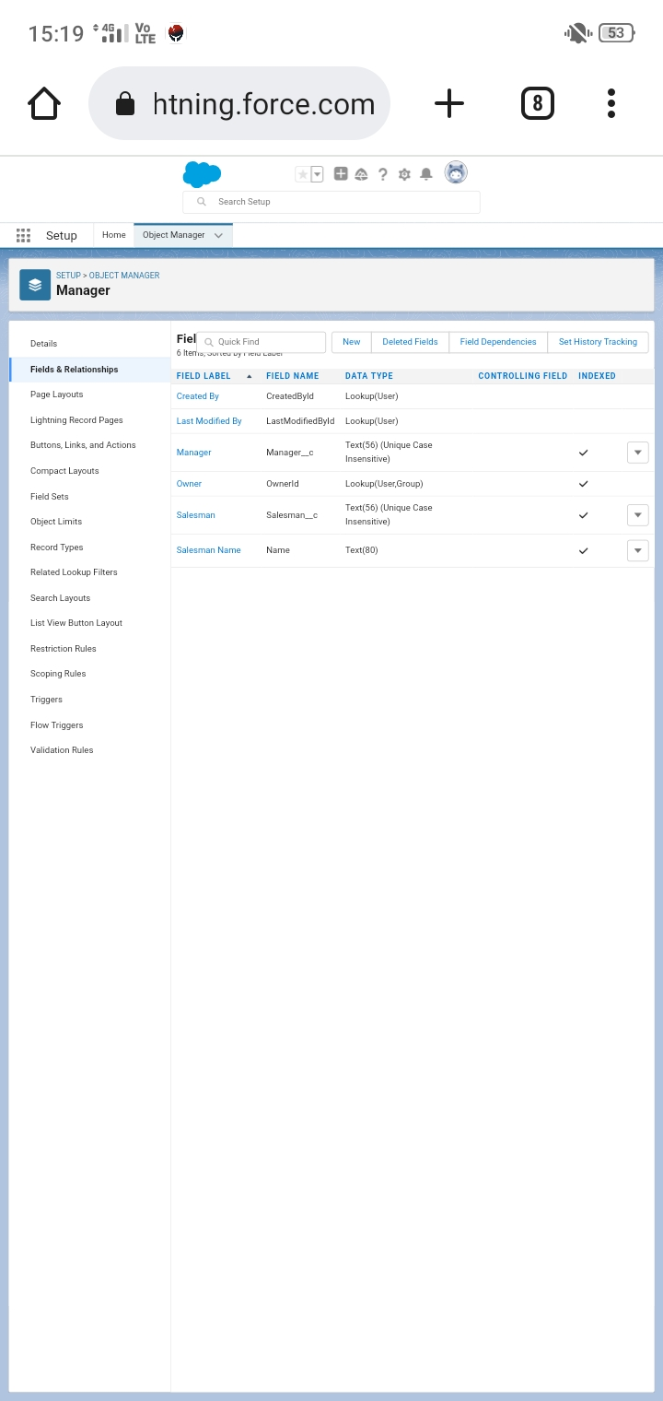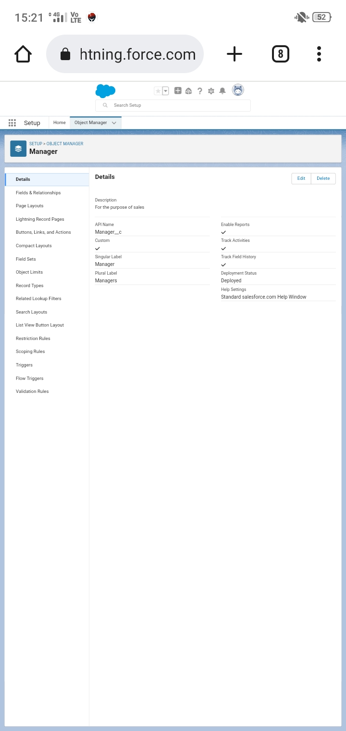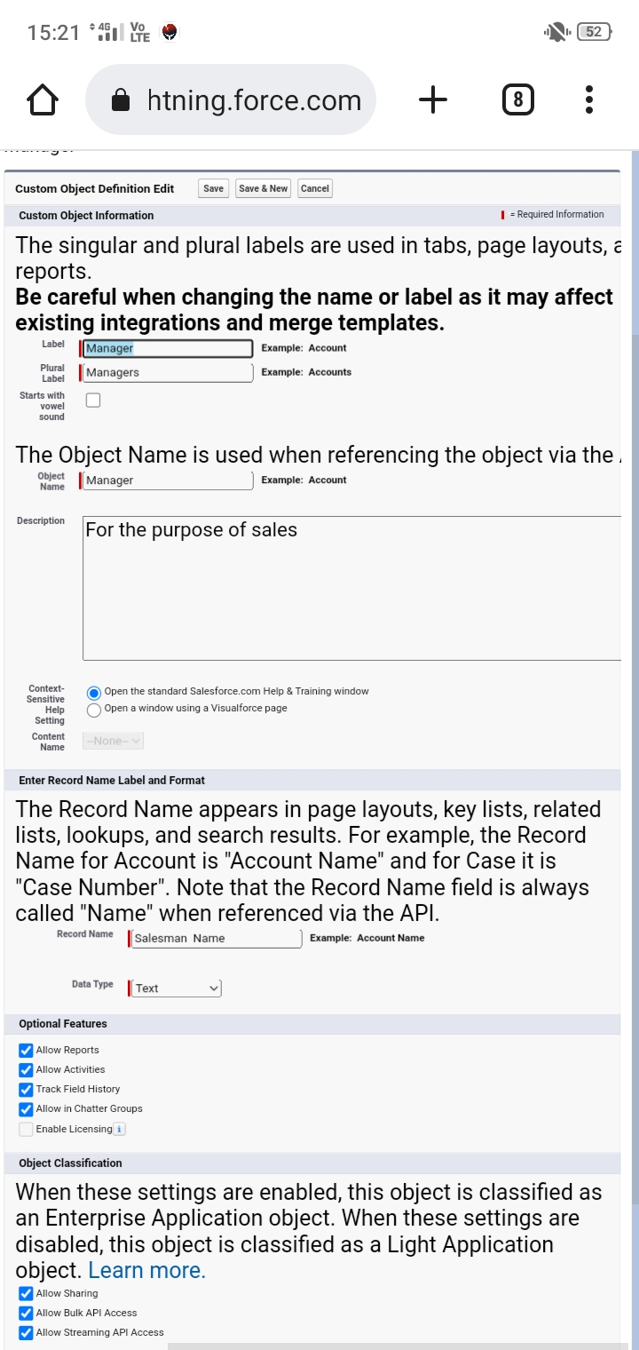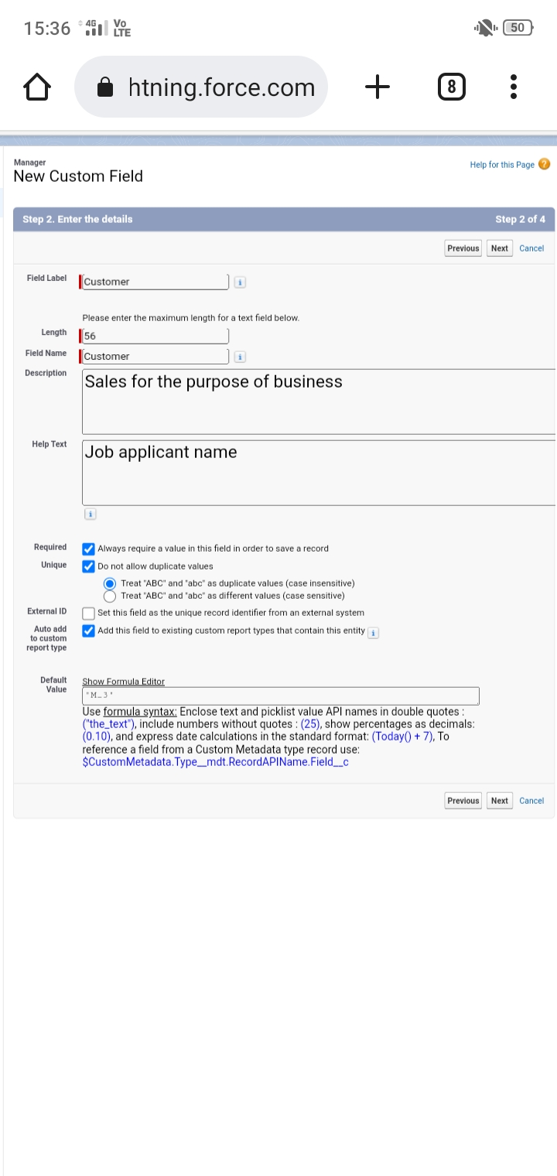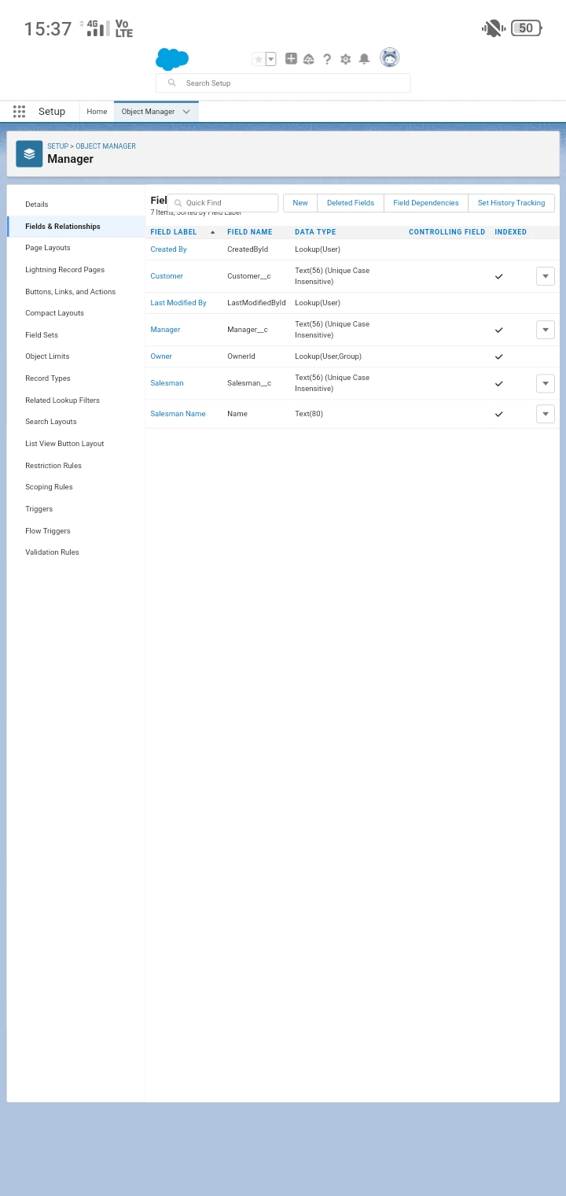4. Trailhead Profile public URL

Team Lead : <https://trailblazer.me/id/thangam498>

Team Member 1 : <https://trailblazer.me/id/mmathavan3>

Team Member 2 : <https://trailblazer.me/id/manip68>

Team Member 3 : <https://trailblazer.me/id/kannan07>

Team Member 4 : <https://trailblazer.me/id/dharshans45>

Advantages and Disadvantages

⋆ You can work with many different people

⋆ HR managers can build a strong business network

⋆ Human resources managers can work indoors

Disadvantages

⋆ HR managers don’t learn many hard skills

⋆ You are replaceable pretty easily

⋆ You have to dress up for work

Applications

⋆ Provides assistant to the HR executive in resolving complex issues

⋆ Process employees requests

Conclusion

Highly qualified recruiting assistant with experience in the industry enjoy creative problem solving and getting exposures on multiple projects

Feature scope

The ability to understand external trends,apply insights to business strategy and align HR in an impactful, customer focused way

HR professionals need to became a specialist in atleast one functional competency and a generalist in four core HR competencies